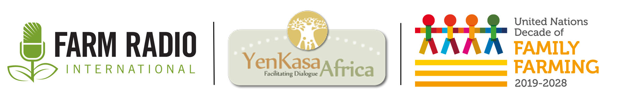

Backgrounder
July 2020

___________________________________________________________

UN Decade of Family Farming
___________________________________________________________

Introduction

The United Nations declared 2019 to 2028 to be the Decade of Family Farming (UNDFF). This is an opportunity to recognize the important role of family farming in the Sustainable Development Goals. It’s also an opportunity to recognize the important role family farmers play in eradicating hunger and shaping the future of food systems. The activities surrounding this Decade of Family Farming are being led by FAO and IFAD, but will take place at local, national, regional, and international levels.

Why is the Decade of Family Farming important to listeners?
- Many of your listeners are probably family farmers, so this decade aims to celebrate them and share their voices.
- Family farmers play important roles in rural development, environmental sustainability, and food security. Thus, they contribute to vibrant communities and healthy economies, as well as the success of the Sustainable Development Goals.
- Family farmers play an important role in food systems, and so they need good information on opportunities and they need their challenges to be heard by policy-makers.

What is family farming?

Family farmers are small- and medium-scale food producers, including peasants, indigenous peoples, traditional communities, pastoralists, fishers, mountain farmers, and many other groups. Family farming is family-managed and operated. It includes agricultural, forestry, fisheries, pastoral, and aquaculture production. These operations rely on the labour of both men and women.

What are some key facts about family farming?
- Family farming is the predominate form of food and agricultural production globally and produces over 80% of the world’s food supply in terms of value.
- Family farming ensures food security, improves livelihoods, better manages natural resources, protects the environment, and contributes to sustainable development, particularly in rural areas.
- There are more than 600 million farms in the world. More than 90% are run by an individual or a family and rely primarily on family labour.
- 90% of fisheries are small-scale operators. Small-scale fisheries account for half of the fish capture in developing countries.
- An estimated 200 million pastoralists herd their animals on rangelands that cover one-third of the earth’s land surface.
- Family farmers include forest communities. Around 40% of the extreme rural poor live in forests and savannahs.
- Women make up nearly 50% of agricultural workers in sub-Saharan Africa, but own only 15% of agricultural land.

Key information

- The UNDFF Pillars for Action
The seven UNDFF pillars help identify crosscutting issues related to the Sustainable Development Goals. These pillars help to identify priorities, plans, and partnerships at local, national, regional, and international levels.

- Promote family farming
Family farmers play an essential role in rural development, environmental sustainability, and food security. They grow much of the food we eat and create jobs for many people. Family farmers need support from government policies that allow them to access natural resources and productive inputs. They also need to be heard by governments and institutions so that policies reflect their needs.
Family farmers are particularly important during crises/emergencies, when they may be more vulnerable but can also play a critical role in national food security.
- Youth in agriculture
When youth enter farming, they bring a number of resources that allow for innovation in the farming, fishing, and forestry sectors. They bring skills, networks, capital, technologies, marketing, and management practices. Youth are needed in agriculture to ensure that farming traditions continue and to ensure that communities can feed themselves.

- Gender equality
Women farmers are essential to achieve sustainable, productive, and inclusive food systems. Women contribute not only with their labour, but also with their knowledge of agricultural practices and biodiversity. Yet they are more likely to suffer a lack of respect for their human rights. They are also among those most affected by poverty and social exclusion. For more on gender inequalities, read these backgrounders:
- Gender inequalities in land rights in Africa
- Rights of rural women in Mali

- Strengthen farmers’ organizations
Family farmers are organizing all around the world to adequately respond to the multiple challenges they face. Producer organizations exist at the local, national, and regional levels. These organizations can provide basic services and capacity development to farmers, and also advocate on their behalf. Local farmers’ organizations know local farmers’ needs and can provide a link for consultations with farmers. For more information, visit the Pan-African Farmers’ Organisation: http://pafo-africa.org/?lang=en

- Support family farmers
Family farmers too often face poverty and the highest levels of economic, financial, social, and environmental risk. Drought, floods, pest infestations, and other crises can have a large and lasting effect on family farmers’ production. Farmers would be more resilient if they had ready access to basic services, infrastructure, social protection systems, and better markets.

Family farmers have been particularly vulnerable during the COVID-19 pandemic. Many lack access to good information and knowledge-sharing during this crisis, so it has been difficult for them to take action to stay safe and mitigate the effects on their livelihoods. In many places, markets and transportation have been disrupted, which has affected the entire agricultural value chain.

- Sustainability
It is important that food and agriculture systems are sustainable. They should provide economic and social opportunities, while also protecting the ecosystems upon which agriculture depends. This includes protecting forests, water, soil, and the general environment. Farming needs to be climate-smart, environmentally sensitive, and contribute to the mitigation of climate change. Climate change is having a clear effect on farmers as weather patterns become more variable and unpredictable. Small-scale farmers are particularly vulnerable to these changes as most depend on rain-fed agriculture.

- Synergies
Farmers are men and women who live and raise families in communities, have religious and cultural practices, and participate in their society. They are part of value chains and economies. They affect the ecosystem around them. Farmers also provide links between rural and urban areas. They provide innovation and employment. They live complex lives that are affected by and have an impact on the environment, the economy, society, technology, and more. This is a rapidly changing world, and farmers have a significant role to play.

For more information, see document 6.

- Family Farmers and the Sustainable Development Goals
A key aspect of the UNDFF is the link between family farmers and the Sustainable Development Goals (SDGs). Family farmers are essential for achieving many of the SDGs, which in turn support family farmers. Here is a look at how the goals of the UNDFF overlapping with the SDGs:

- Farmers shift from subsistence to income-generating opportunities (Goals 1 & 10)
- Family farmers use resilient and productive agricultural practices (Goal 2)
- Family farmers and their organizations have the capacity to serve their communities (Goals 16 & 17)
- Family farmers and their organizations deliver inclusive rural services (Goals 3, 4, 6, & 7)
- Women farmers are empowered to contribute to sustainable, productive, and inclusive food systems (Goal 5)
- Family farmers are supported to contribute to developing more sustainable food systems (Goal 12)
- Family farmers promote food systems that are more resilient to climate change (Goal 13)
- Family farmers preserve biodiversity, the environment, and culture (Goals 14 & 15)
- Family farmers enable diversified food systems that create jobs, including for youth (Goals 8 & 9)
- Food systems strengthen sustainable integration between urban and rural areas (Goal 11)

For more information, see documents 6 and 15.

- Family Farmers and the coronavirus pandemic

The coronavirus pandemic has affected farmers and rural communities across Africa in many ways. The pandemic, government responses, and related precautionary measures have affected farmers’ work, production, access to markets, and ultimately their income. It has also had an impact on the food and nutrition security of people living in rural and in urban areas. Here are some ways that farmers and value chains have been affected by COVID-19:

Production

Access to inputs: Many farmers will face reduced access to inputs such as seeds, fertilizer, etc., due to transportation or production restrictions, which may reduce availability or affordability of inputs. For example, Nigeria typically imports many chemical inputs and seeds from overseas. There have been fewer international flights, reducing the availability of these inputs, and transportation restrictions have made it difficult to get the inputs to farmers. Even local seed producers may have trouble selling to farmers when markets are closed. Seed certification processes may also be delayed, reducing the availability of certified seeds for farmers.

Farmers have also lost access to some extension services due to COVID-19, as many field demonstrations have been cancelled. Radio, mobile phones, and apps will be more important tools for farmers who have questions.

For more information, see document 9.

Access to labour: In many places, access to farm labour is currently limited. In some places, transportation bans have meant that family members or hired labourers cannot reach work areas. In some places, governments have implemented curfews, which may mean that farmers can only travel to their farms at certain times of the day, possibly forcing them to work in the heat of the day. This may make some production practices more challenging, and mean that farmers can only plant on part of their land.

It may also be more difficult for farmers to work collectively or to hire labourers, as labourers still need to practice physical distancing in order to ensure the health and safety of everyone.

One solution is for farmers to consider planting less labour-intensive crops, such as those discussed in this script: Story ideas to help rural communities cope with labour shortages and other impacts of HIV and AIDS

For more information, see document 2.

Well-being: It is important that farmers, their family, and their labourers take appropriate measures to stay healthy. This includes practicing physical distancing, frequent handwashing, and good social etiquette, such as avoiding spitting and touching your mouth and nose. If a farmer or their family falls sick with COVID-19, it may affect their production and their income.

Marketing

Transportation: Some governments have implemented travel restrictions in order to limit the spread of COVID-19. While this may not affect the transportation of products, it may still affect farmers’ ability to transport their goods to market or to middlemen.

Border closures have also restricted the movement of products from one country to the next, which may affect the demand for farmers’ crops in specific areas and the availability of food products, and therefore prices, in another area. For example, tomato farmers in Cameroon have seen a dramatic drop in prices because their tomatoes can no longer be transported to Nigeria, Equatorial Guinea, Gabon, Chat, Congo, and Central African Republic. In these cases, supporting local farmers and local production can help ensure food security and income in your area.

Border closures may also restrict nomadic herders who must move their animals in search of fodder or water, or to find markets to trade their animals. For example, many Mauritanian herders head to Mali and Senegal in search of pasture. Border closures may mean that their animals cannot get enough food or water, or that herders cannot trade their animals for other essential items.

For more information, see documents 4 and 12.

Access to markets: In many countries, agriculture has been deemed an essential service, and governments are trying to reduce the impact of their restrictions on farmers and markets. However, marketplaces are usually busy, crowded places with limited physical distancing and handwashing, making them dangerous for the spread of coronavirus. In some places, markets have closed, or vendors or customers don’t feel comfortable visiting. Vendors and consumers should be cautious and follow good hygiene practices when visiting marketplaces.

The closure of marketplaces or reductions in clientele have affected the incomes of farmers and vendors. In some cases, vendors have had to sell different products, sell from their homes, and rely in mobile phones for a direct line to their customers. In other places, farmers are relying more on mobile apps, mobile money, and other technologies to sell their products.

The pandemic has also affected other areas of the economy, which in turn affect the demand for farmers’ products. For example, the closure of hotels, restaurants, and schools reduces the demand for farmers’ products.

For more information, see documents 2, 11, 12, and 13, several of which are Farmer stories.

Post-harvest processing

Closure of processing factories: Many processing plants and factories may be reducing their production or closing their doors in response to government restrictions related to COVID-19. In order to reduce the spread of coronavirus amongst their employees and to practice physical distancing, they may reduce the number of staff on site, reducing production levels. Other businesses may need to reduce production because they cannot get crops from farmers or because demand has fallen, as stores, restaurants, hotels, and other businesses serve fewer customers.

For more information, see document 1, a Farmer story.

Crop storage: With the closure of marketplaces or restricted access to markets, farmers may need to store their crops longer, either to sell at a later date or for home consumption. This may mean that farmers switch to planting more cereal crops, as they are easier to store. Or, farmers may need to adopt different crop storage practices, such as using cooling chambers or drying vegetables.

For more information on crop storage, see document 8: a theme pack on crop storage.

Finance

As farmers face new challenges due to the health crisis, many will face financial hardships, either due to loss of income, inability to access finance or repay loans, or unexpected costs. Some organizations are calling for financial support for farmers. This could include setting a floor price or purchasing farmers’ stocks either to store or to use at government institutions, such as hospitals. This could loans include relieving certain payments, including taxes or utilities, forgiving loans, or providing grants.

For more information, see documents 2 and 9.

Home situations

Awareness, knowledge, and skepticism: Farmers and rural communities may have less access to information on COVID-19 and so be less aware of the symptoms, spread, and treatment of COVID-19. With less access to good information, skepticism, myths, and stereotypes may arise. It’s important that good information about this pandemic reaches rural communities so that they can take appropriate steps to protect their families, and so that myths and stereotypes do not spread.

Children: In many countries, schools have been closed in order to prevent the spread of COVID-19. This means that children are at home all day, which means additional childcare duties for parents. These additional duties may mean that parents, particularly women, have less time for their farming activities.

For more information, see document 14.

Prioritization of sanitary measures: Farmers should prioritize sanitary measures, including physical distancing, frequent handwashing, and wearing a mask if in close proximity to other people. This may mean farmers need to set up handwashing stations on their farm and in their home. Farmers may also need to rely more on family support rather than neighbours or hired labour. Ultimately, family farmers are family-run businesses, and so the health of the business and the health of the family are mutually important.

For more information, see document 7: Key information on COVID-19 for broadcasters.

Definitions

FAO: The Food and Agriculture Organization is an agency of the United Nations that leads international efforts to defeat hunger and improve nutrition and food security.

IFAD: The International Fund for Agricultural Development is an international financial institution and agency of the United Nations that works to address poverty and hunger un rural areas of developing countries.

Sustainable Development Goals: Adopted by the UN member states in 2015, these 17 goals are a “blueprint for peace and prosperity for people and the planet, now and into the future.” They are also a call for action by all countries to improve the lives of people around the world and improve the environments in which they live. To learn more: https://sustainabledevelopment.un.org

Where can I find more resources on this topic?

Documents

- Combray, V. and Dieudonné, E., 2020. Burkina Faso: Government measures impact agrifood businesses. Barza Wire, May 25, 2020. https://wire.farmradio.fm/farmer-stories/burkina-faso-government-measures-impact-agrifood-businesses/
- FAO, 2020. How is COVID-19 affecting the fisheries and aquaculture food systems. http://www.fao.org/3/ca8637en/CA8637EN.pdf
- FAO, 2020. Introducing the UN Decade of Family Farming. http://www.fao.org/family-farming-decade/home/en/
- FAO, undated. COVID-19 could not have come at a worse time for vulnerable communities in West Africa. http://www.fao.org/news/story/en/item/1271835/icode/
- FAO, undated. United Nations Decade of Family Farming. Family Farming Knowledge Platform. http://www.fao.org/family-farming/decade/en/
- FAO and IFAD, 2019. United Nations Decade of Family Farming 2019-2028: Global Action Plan. http://www.fao.org/3/ca4672en/ca4672en.pdf
- Farm Radio International, 2020. Key information on COVID-19 for broadcasters. http://scripts.farmradio.fm/radio-resource-packs/covid-19-resources/key-information-covid-19-broadcasters/
- Farm Radio International, 2020. Store food longer to cope with food shortages: theme pack. http://scripts.farmradio.fm/radio-resource-packs/theme-packs-2020/store-food-longer-cope-food-shortages/
- ICRISAT, 2020. What African farmers and processors say about the COVID-19 pandemic and lockdowns. https://reliefweb.int/report/world/what-african-farmers-and-processors-say-about-covid-19-pandemic-and-lockdowns
- Karl, M, 2020. COVID-19: Tomato farmers commit suicide following poor sales. The Voice News. http://www.thevoicenews.net/2020/07/04/covid-19-tomato-farmers-commit-suicide-following-poor-sales/
- Khomo, L, 2020. Malawi: COVID-19 social distancing measures disrupt markets and farmers’ income. Barza Wire. https://wire.farmradio.fm/farmer-stories/malawi-covid-19-social-distancing-measures-disrupt-markets-and-farmers-income/
- Lufungulo, E., 2020 Tanzania: COVID-19 forces female vendors to sell in new ways. Barza Wire. https://wire.farmradio.fm/farmer-stories/tanzania-covid-19-forces-female-vendors-to-sell-in-new-ways/
- Ongeng, D, 2020. Uganda: COVID-19 ban on livestock markets makes life difficult for chicken farmer. Barza Wire. https://wire.farmradio.fm/farmer-stories/uganda-covid-19-ban-on-livestock-markets-makes-life-difficult-for-chicken-farmer/
- Traoré, S, 2020. Burkina Faso: Women are changing their daily routines because of additional burdens during COVID-19. Barza Wire. https://wire.farmradio.fm/farmer-stories/burkina-faso-women-are-changing-their-daily-routines-because-of-additional-burdens-during-covid-19/
- YenKasa Africa, 2020. CSOs speak of policy, peace, post-harvest loss in statement to FAO Africa Regional Conference. https://www.yenkasa.org/csos-speak-of-policy-peace-post-harvest-loss-in-statement-to-fao-africa-regional-conference/

Farmers’ organizations

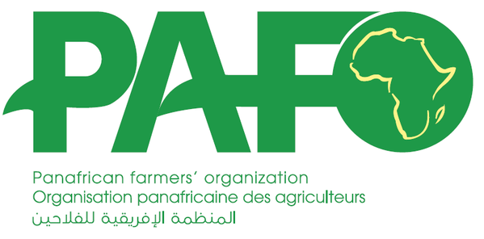 Pan-African Farmers’ Organization: http://pafo-africa.org/
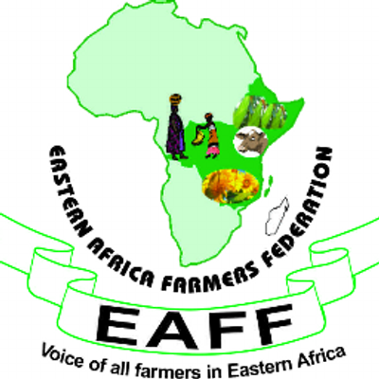 East Africa Farmers’ Federation: http://eaffu.org/

Plateforme régionale des organisations paysannes d’Afrique
Centrale (PROPAC): http://infopropac.org/

Réseau des organisations des paysannes et des producteurs
agricoles de l’Afrique de l’Ouest (ROPPA):
http://roppa-afrique.org/
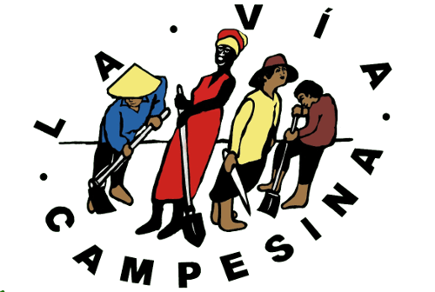
La Via Campesina: https://viacampesina.org/en/

Acknowledgements

This resource was supported by YenKasa Africa, with funding from the UN’s Food and Agriculture Organization. YenKasa Africa is a platform to enhance knowledge and experience sharing to support agriculture and rural development in sub-Saharan Africa.

Farm Radio International is the communication partner for the UN Decade of Family Farming 2019-2028.

